**EDI Processing Errors 04-2025**

**Error – Varying Descriptors in Charge Descriptions**

Charges can’t be processed because charge descriptions include changing usage amounts, rates, and dates.

* **Direct Energy**

There are some unassigned charges added to OneTime.SAC EDI TAble Info: SACAgencyServicePromotionAllowanceorChargeCode = Fixed Price - 2,155 kWh Total @ $0.09499/kWh and SACDescription = Fixed Price - 2,155 kWh Total @ $0.09499/kWh

There are some unassigned charges added to OneTime.SAC EDI TAble Info: SACAgencyServicePromotionAllowanceorChargeCode = TX-ERCOT Admin Fees - CIL - 950 kWh Total @ $0.000079 /kWh-F and SACDescription = TX-ERCOT Admin Fees - CIL - 950 kWh Total @ $0.000079 /kWh-F

* **Duke Energy**

There are some unassigned charges added to OneTime.SAC EDI TAble Info: SACAgencyServicePromotionAllowanceorChargeCode = Summary of Rider Adjustments - Apr 01 to Apr 07 and SACDescription = Summary of Rider Adjustments - Apr 01 to Apr 07

* **PG&E**

There are some unassigned charges added to OneTime.SAC EDI TAble Info: SACAgencyServicePromotionAllowanceorChargeCode = Usage Charge 39.32 th @ $1.0110 and SACDescription = Usage Charge 39.32 th @ $1.0110

* **Ameren**

There are some unassigned charges added to OneTime.SAC EDI TAble Info: SACAgencyServicePromotionAllowanceorChargeCode = Purchased Elec Non-Summer 0-800 kWh and SACDescription = Purchased Elec Non-Summer 0-800 kWh

There are some unassigned charges added to OneTime.SAC EDI TAble Info: SACAgencyServicePromotionAllowanceorChargeCode = Energy (43708KWH @ $0.0587) and SACDescription = Energy (43708KWH @ $0.0587)

**Error – Random failures to pull meter, charges, and other data.**

Sporadically, some invoices will fail to pull data associated to meter information, partial charges, or all charges regardless of matching service IDs between what’s setup in Expense Logic and what is listed on the EDI file.

* **Ameren**
* **Dominion**
* **Duke Energy**
* **FPL**
* **PSEG**
* **Southern Company Electric**



**Error – Automated error emails for incorrect Account Numbers or Service IDs no longer generate.**

In the past, emails would generate and be sent to recipients to highlight if an account number or service ID needed to be changed. These emails stopped generating as of 4/2024, but service ID changes have still been found to occur and cause errors to pull invoice data.

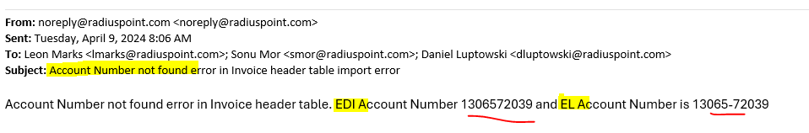

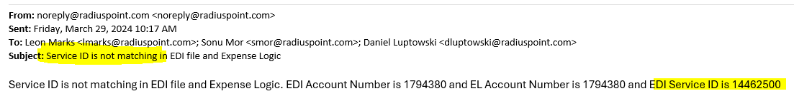

**Error – Invoices will fail to process from file without notice due to mismatching service IDs.**

PG&E Convergent files will fail to be imported from the files into the dashboard if meter IDs do not match.

There is no notification to advise account failed to process from file.